**SAMPLE POST-RESTRAINT ASSESSMENT FORM**

**School District Name Here**

|  |
| --- |
| **Student Name:_________________________________________________________ DOB: ____________ Teacher/HR:____________________________________________ N/A**  **Date: _____________ Time: ___________ Location: __________________________________________ Conducted by:____________________________________________________________ (*Signature & Title*)** |

**Vital Signs:** BP______ /______ PULSE_________ RESP_________

**Pain Assessment**

□ Denies Pain □ Other_______________________________________________________________________

**Please check all that apply**

|  |  |
| --- | --- |
| **LOC**  □ Alert □ Other______________________________  **Orientation** □ Person □ Place □ Time □ Situation | **Head**  □ No external signs of injury  □ Pupils equal and reactive  □ Other_____________________________________ |
| **Neck**  □ Supple/full ROM  □ Other_____________________________________ | **Chest/Respiratory Assessment**  □ No visible injury □ Respiratory Status WNL  □ Other____________________________________ |
| **Back**  □ No external signs of injury  □ Other_________________________________ | **Abdomen**  □ No external signs of injury  □ Other_____________________________________ |
| **Upper Extremities**  Right Arm  □ Full ROM □ Other___________________________  Left Arm  □ Full ROM □ Other___________________________ | **Lower Extremities**  Right Leg  □ Full ROM □ Other___________________________  Left Leg  □ Full ROM □ Other___________________________ |
| **Skin Assessment** □ WNL □ Other -SEE BELOW  □ Abrasion (description) ____________________________________________________________________ □ Bruise (description) ______________________________________________________________________  □ Swelling(description) _____________________________________________________________________  □ Wound (description)______________________________________________________________________ | |

Page 1 of 2

**LOCATION OF EVIDENT MARKS OR INJURIES**

1. **Shade** the areas not inspected under clothing

2. **Circle** area of suspected injury and assign a number (e.g. bruise 1, 2, abrasion 3, swelling 2, etc.)

**3. Describe** mark or injury on next page**.**

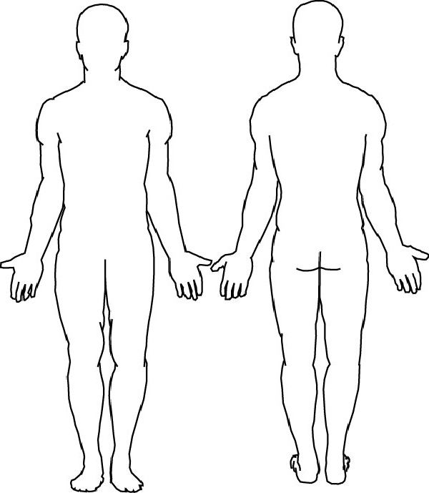

**Additional Documentation**:

___________________________________________________________________________________________

___________________________________________________________________________________________

___________________________________________________________________________________________

___________________________________________________________________________________________

____________________________________________________________________________________________________________________________________________________________________________________________________________________________________________________________________________________________________________________________________________________________________________

Sample NYSCSH Resource available at www.schoolhealthny.com 9/2017

Page 2 of 2